Nov 11 2026:
Testing
Using YOLOCrackTry1.py run the YOLO model based on the best.pt weights
- Test outside on sidewalk cracks with only sidewalk in the frame
- Test with a person walking by
- Test with a sewer cover near a sidewalk crack
Results:
- Sidewalk cracks did not receive confidence of over 90%
- People shoes received a confidence of over 90% that they were cracks
- Sewer covers were also detected as cracks
- Gaps between sidewalks were identified as cracks
Before post-processing the image and using for example PCA, we need to add more images to the training set which shows peoples feet, sewer drains, grass and road on either side of the sidewalk.
Next steps:
- The team took a gimble and recorded a video of sidewalks with peoples feet, sewer drains, grass and the road, and is currently in the process of annotating the images before we can re-train the model.

Nov 10 2026
Testing:
The team found a bank of images with labels from https://github.com/CHDyshli/HrSegNet4CrackSegmentation?utm_source=chatgpt.com, in a file concrete3k.
We want to use instance segmentation so in the future we can work with the shape of the cracks to distinguish features. However, the concrete3k, segmentation annotations were stored in PNG not polygon formatted TXT files, which does not match the YOLO model. The dataset also used semantic segmentation, which is every pixel, whereas instance segmentation is a separate pixel-level mask for each detected object.
We decided to use YOLOv26s, as it has lower latency than larger models, but has higher accuracy than nano.
We created a file (ConvertDataSet.py) which reads in the images and labels and then outputs the labels as text files with instance segmentation coordinates (captures vertex, applies polygons).
We then visualized the data in Roboflow to see the imposed cracks inspection on the image. Afterwards we then trained the model. We took the weights of our YOLO model (best.pt) and ran YOLOCrackTry1.py for crack detection.
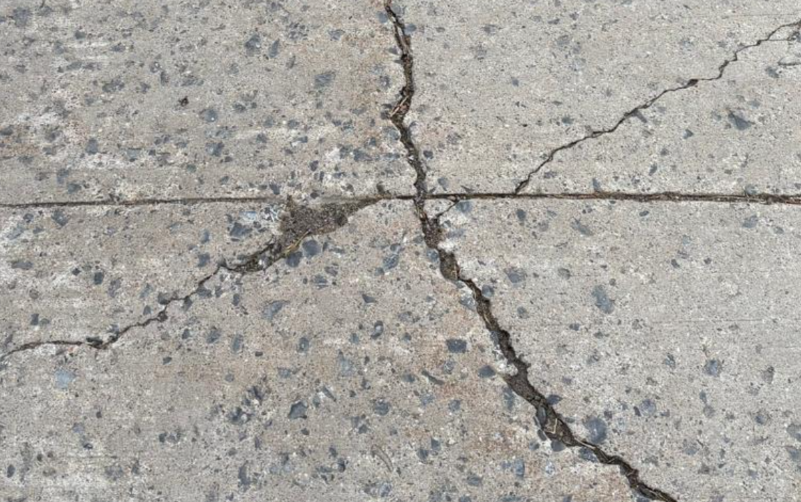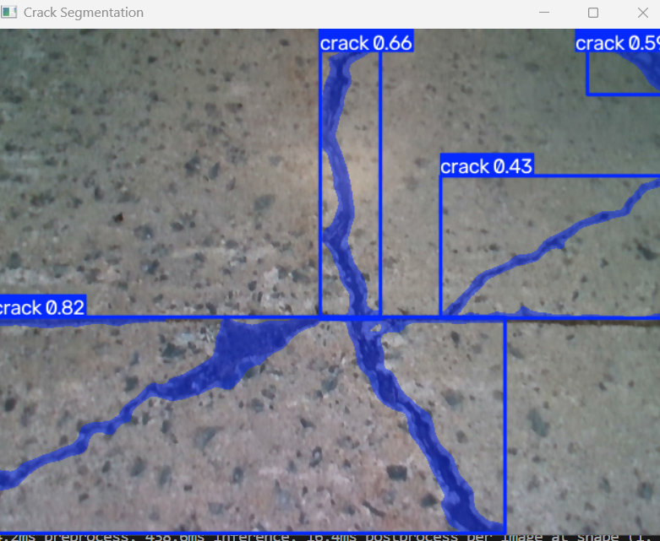
Figure 1 – Shows the YOLO model trained on the sidewalk cracks tested on a photo displayed on a monitor of a campus sidewalk crack
The crack detection capability of our YOLO model is sufficient; however, other issues that came up while testing was sewer covers were recognized as cracks, along with people’s shoes. This could provide false data.
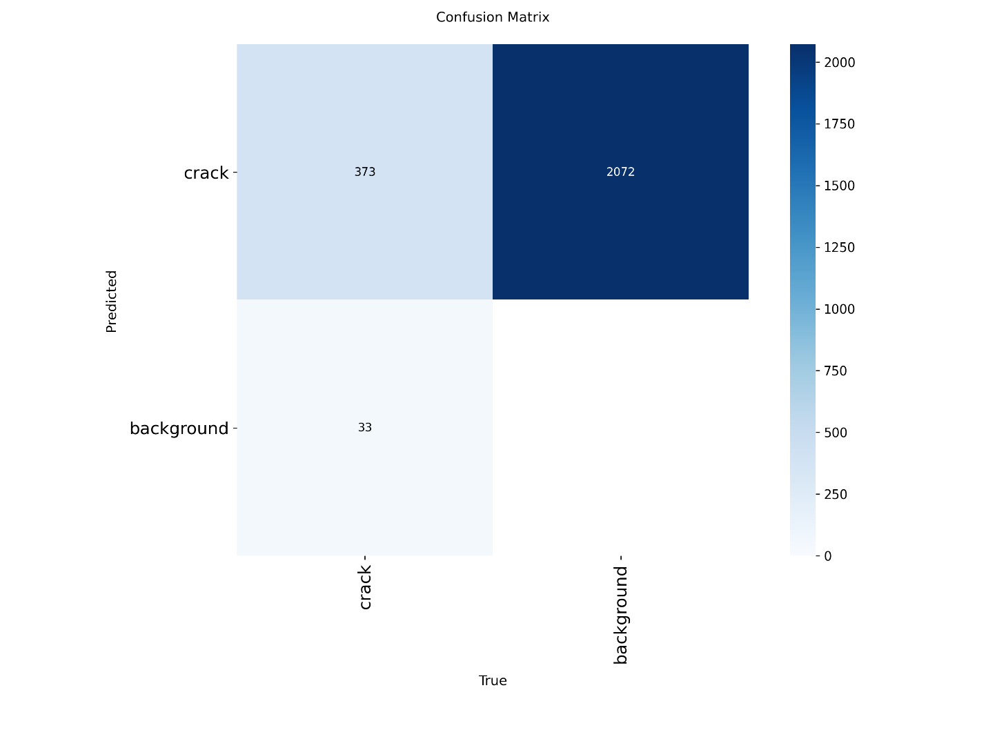
Figure 2: Confusion Matrix of YOLO26 Model
The model was trained for a maximum of 200 epochs with an early stopping patience of 30. Training terminated early at Epoch 115 (~2.08 hrs). Best weights (best.pt) were achieved at Epoch 85 with a Box mAP@50 of 84.6% (mAP@50–95: 70.1%, Precision: 89.3%, Recall: 78.2%) and Mask mAP@50 of 80.8% (mAP@50–95: 53.9%, Precision: 88.5%, Recall: 76.0%).
On the validation set, the model caught 91.9% of all real cracks (373 found, 33 missed). At YOLO's default low confidence setting (conf=0.25), it also flagged 2,072 background false alarms, so we will need to raise the confidence threshold during deployment to filter out background noise and keep precision high (~88.5% at optimal threshold).unmatched prediction is labelled “crack,” so this column normalizes to 1.00 whether there is one false detection or thousands. Ultralytics normalizes each column separately.

Next steps:
- We need to add pre-processing to isolate our ROI, such as if there is grass (green) or the road (dark grey/black), remove those before inputting the image into the YOLO model
- Determine how to use the values read in from the pixel segmentation to eliminate the gaps between sidewalks, so they are no longer recognized as cracks. Likely using PCA.
- Annotate our own photos and re-train the model.

